|  |  |
| --- | --- |
| **Name** | Muhammad Asad |
| **Reg. #** | 2019-EE-383 |
| **Marks** |  |

## Objectives:

**EXPERIMENT# 6**

# Stepping Motor in full step mode

1. Step angle & steps/revolution calculation in full step mode.
2. Determine the step angle in full step mode.
3. Determine the maximum frequency in full step mode.

## Apparatus:

1. Stepping Motor card
2. Lucas-Nulle unitrain module
3. PC
4. Connecting wires

## Theory:

Stepping motor has three types 1.Rluctance 2.Synchronous 3.Hybrid. Hybrid is

best among them as it enjoys the advantages of both reluctance and synchronous. Hybrid is further divided in full step and half step mode depending upon the control circuitry of stepper motor. In this experiment we will see the full step mode in detail.

Full-step mode can be divided into "**single-phase mode**", where only one phase is under current and "**two-phase mode**", where there are always two phases being supplied with current. The differing application of current affects the corresponding cogging torque and operating torque. Single-phase operation is seldom used and we will not investigate it in detail.

The following illustration in fig 8.1 shows the pattern for the current and the alignment of the stator flux that results for full-step mode in two-phase operation. Here it is assumed that the two stator windings are supplied with currents of ISa and ISb. Under such circumstances, the alignment of the stator flux changes in each case by 90°. The rotor lags behind as a result of the inertia of its mass and when there is no load, it aligns in the direction of the resultant stator flux.

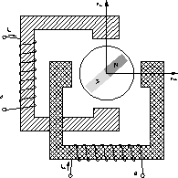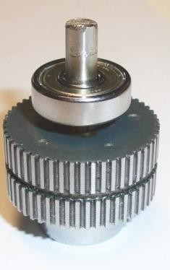

Fig 8.1 Full Step Mode& Hybrid Stepper Motor

The **maximum frequency** of a stepper motor specifies the maximum frequency at which the motor can be operated and still attain each position with certainty. The maximum frequency is also determined by the load. This means that as the torque to be applied becomes greater, the maximum frequency becomes smaller.In the illustration fig 8.2 it can be seen how the torque reduces with frequency.

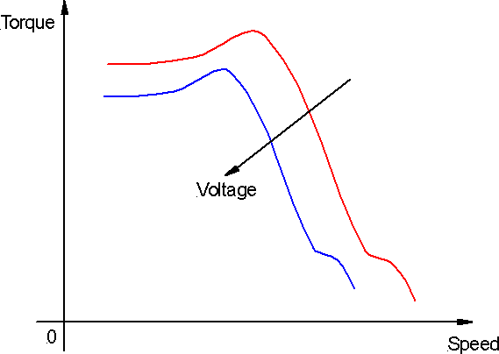

Fig 8.2 Torque speed Curve

## Step Angle & steps/ Revolution Measurement: Procedure:

* 1. In this exercise you will determine the step angle of the stepper motor based on mechanical aspects. The step angle is defined for full-step operation, as are the other parameters referring to the motor.
  2. In permanently excited stepper motors rotor requires as many steps for one revolution as the stator field does. In full-step mode that comes to 4 steps. If more poles are added to the motor, so that the poles alternate (each pole electrically 180° out of phase with the next), then more steps need to be undertaken to complete a full revolution.
  3. In hybrid motors there are 10 north poles and 10 south poles. There are also 2 phase windings that are distributed over 4 windings in total. That means there are ten times as many poles as there are in the permanently excited stepper motor. As a result, 10 times as

many steps are required for a revolution. This means the hybrid motor illustrated there needs 40 steps in full-step mode and 80 steps in half-step mode.

* 1. This rotor has 100 teeth altogether. That implies 50 north poles and 50 south poles. Determine from the data provided to you how many steps are required per revolution.
  2. Check your results on the actual motor.
  3. Let the motor rotate with a multiple of the calculated steps per revolution. If the value is correct, the needle will continue to remain in its initial position.
  4. Assemble experiment in full step mode as shown in fig 8.3.Open the Stepper Control Unit virtual instrument from the Stepper Motor sub-menu under Instruments. Configure the settings as in the graphic below

many steps are required for a revolution. This means the hybrid motor illustrated there needs 40 steps in full-step mode and 80 steps in half-step mode.

* 1. This rotor has 100 teeth altogether. That implies 50 north poles and 50 south poles. Determine from the data provided to you how many steps are required per revolution.
  2. Check your results on the actual motor.
  3. Let the motor rotate with a multiple of the calculated steps per revolution. If the value is correct, the needle will continue to remain in its initial position.
  4. Assemble experiment in full step mode as shown in fig 8.3.
  5. Open the Stepper Control Unit virtual instrument from the Stepper Motor sub-menu under Instruments. Configure the settings as in the graphic below.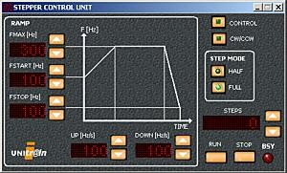
  6. Multiply the number of steps per revolution by 5 and enter this value into the **STEPS**

field. Multiplying by five exaggerates the effect of any error in the value.

* 1. If calculated steps/revolution is correct motor will complete 5 revolutions to cover these steps
  2. Multiply the number of steps per revolution by 5 and enter this value into the **STEPS**

field. Multiplying by five exaggerates the effect of any error in the value.

* 1. If calculated steps/revolution is correct motor will complete 5 revolutions to cover these steps

## Circuit Diagram:

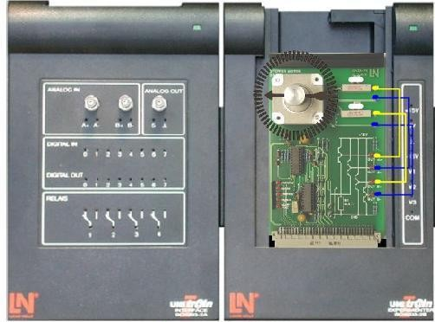

Fig 8.3 Stepper motor in full step mode

.

**Observations:**

The number of steps per revolution is: **200**

Use the following formula to calculate the step angle á. The step angle is the angle the rotor moves from one step to the next.

elma5_FormelSchrittwinkel_gb

The step angle is: **1.8**

If Steps entered in stepper control unit are following then tell the revolutions required by motor

|  |  |
| --- | --- |
| **Steps** | **Revolutions** |
| 200 | 1 |
| 350 | 1.75 |
| 700 | 3.5 |
| 950 | 4.75 |
| 1200 | 6 |

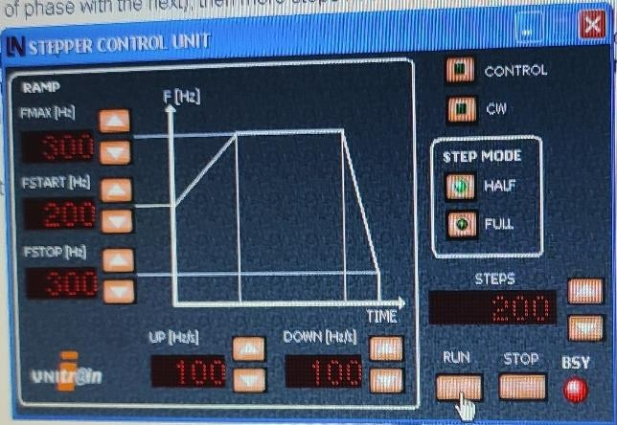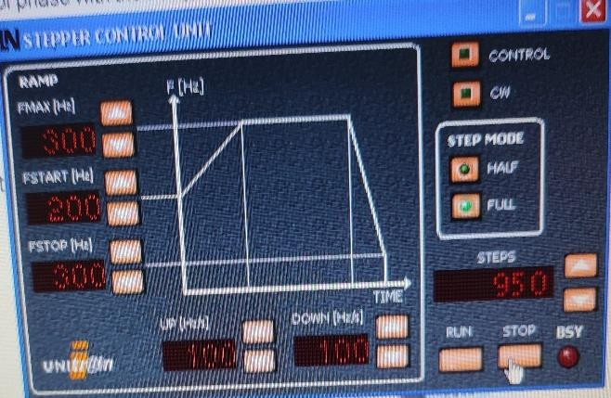

## Maximum Frequency Measurement: Procedure:

* 1. Connect up the stepper motor in full step mode as in pervious section.
  2. Open the Speed Control virtual instrument from the Instruments menu. Set it up as follows:
     1. STEP MODE: FULL
     2. FREQUENCY: 1Hz
     3. POWER on
  3. Raise the frequency in increments until the rotor gets "out of step".

## Observations:

The maximum step frequency for full-step operation with no load is: 20 Hz

### Lab Exercise:

***Task 8.1:*** If a stepping motor has 500 teeth altogether then how much steps will be required by it to complete one revolution in full step and half step mode.

**Conclusions:**

**Describe your observations comments in the space provided.**

In this lab we learnt about the Step angle & steps/revolution in full step mode.Determined the step angle in full step mode and learnt how to find the maximum frequency in full step mode.

|  |  |
| --- | --- |
| **Name** | Muhammad Asad |
| **Reg. #** | 2019-EE-383 |
| **Marks** |  |

## Objectives:

**EXPERIMENT # 7**

# Stepping Motor in Full step Mode.

1. Find maximum start frequency in full step mode.
2. Control signals in full step mode.
3. Direction control of stepping motor in full step mode

## Apparatus:

1. Stepping Motor card
2. Lucas-Nulle unitrain module
3. PC
4. Connecting wires

## Theory:

The start frequency of a stepper motor specifies the maximum speed at which a motor can be initially activated without losing positions. This frequency also depends on the load connected.

## Maximum Start Frequency:

**Procedure:**

* 1. Connect up the stepper motor in full step mode as in fig 9.1.
  2. Open the Speed Control virtual instrument from the Stepper motor sub-menu under Instruments. Set it up as follows:

STEP MODE: FULL FREQUENCY: 300Hz POWER on

* 1. If the motor starts rotating, switch it off and increase the frequency. Determine experimentally in this way the maximum frequency at which the motor will start rotating.

## Circuit Diagram:

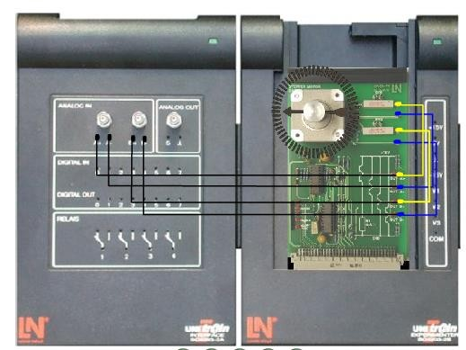

**Observations:**

Fig 9.1 Stepping motor in full step mode

The maximum start frequency as determined by experiment is: 20 Hz

## Control Signals in Full step mode: Procedure:

* 1. Investigate the control signals for the stepper motor in full-step mode.
  2. In order to obtain definitive signals the current regulation that would normally take effect is suppressed by two resistors connected in series with the windings.
  3. Connect up the stepper motor as shown in figure 9.1
  4. Open the Speed control virtual instrument from the Stepper Motor sub-menu under Instruments. Set it up as follows:
     1. Full-step
     2. Frequency: 100Hz
     3. Direction of rotation: CCW
  5. Power on
  6. Open the Oscilloscope virtual instrument from the Measuring Instruments menu. Set it up as follows:
     1. Time/div : 20ms
     2. Trigger : Channel A
     3. Channel A: Volts/div : 10; DC coupling
     4. Channel B: Volts/div : 10; DC coupling
  7. Shift the zero axes so that both channels are visible.
  8. Measure the voltages applied to the windings of the stepper motor. Enter the signals into observations graph.

## Observations:

I determined maximum start frequency in full step mode and Control signals in full step mode managed to focus on Direction control of stepping motor in full step mode.

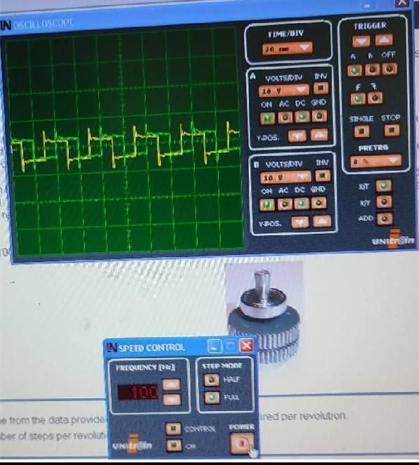

## Q. How do you interpret the signals

1. The signals are phase-shifted by 180
2. The signals are phase-shifted by 90°
3. The output voltage is a square wave
4. The output frequency is 100 Hz
5. The output frequency is 25 Hz

## Q. At what times are steps carried out?

1. On each edge of the motor phase on channel A
2. On each edge of the motor phase on channel B
3. On each edge of the motor phase on both channels

## Lab Exercise :

***Task 9.1:*** Compare the Maximum step frequency with maximum start frequency in full step mode .

**Conclusions:** Describe your observations & comments in space below.

|  |  |
| --- | --- |
| **Name** | Muhammad Asad |
| **Reg. #** | 2019-EE-383 |
| **Marks** |  |

## Objectives:

**Experiment # 12**

# Linear Motor

Measure the induced voltage in linear motor.

## Apparatus:

**Theory:**

1. Linear Motor
2. Lucas-Nulle unitrain module
3. PC
4. Connecting wires

## :Introduction:

To understand how linear motors work, you must first understand how rotary electric motors work, because the principle is exactly the same. The motor shown in the next illustration fig 11.1 consists of a permanent-magnet stator and a three-phase rotor with coil windings named U, V and W. The interaction between the magnetic field of the permanent magnets and the current in the coils produces a force which tends to rotate the rotor.

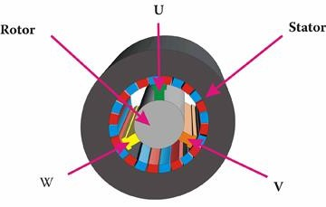

Fig 11.1 Rotary Electric Motor

By a leap of imagination, this device can be transformed into a linear motor simply by cutting open and unrolling it. The cylindrical arrangement of the coils is changed to a flat structure. The same force described above will now produce linear movement. Therefore a rotating motor with a **rotor** and **stator** translates to a linear motor with a **primary part** and a **secondary part.** The primary always features the coils and the secondary part has the permanent magnets. These terms do not necessarily indicate the movable part of a linear motor as either one can be moved. During this course the primary part is movable.

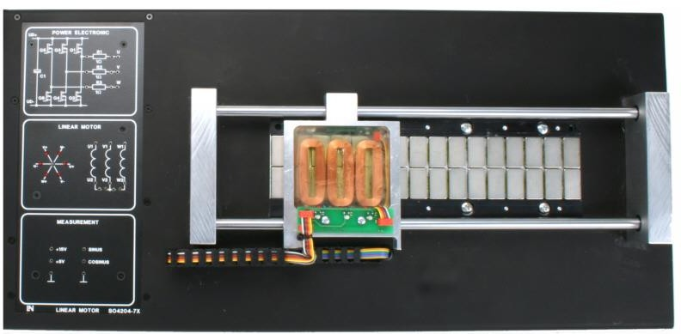

Fig 11.2 Linear Motor

## :Linear motor classification:

The family of electric drives has a huge number of members with different properties. To get a better understanding of the various motors, we categorise different types in various groups. The motors in a group must have at least one common property. Two large groups are based on the properties of "rotary motion" and "linear motion". Therefore we put all motors that produce linear motion in the group "linear motors".

Other properties used for classification are:

* + - Number of phases (typically three)
    - Current applied to the coils (direct current or alternating current)
    - Type of coupling used to couple the primary with the secondary
      * Synchronous = current carrying coils and permanent magnets
      * Induction = current carrying coils and induced current
    - Ratio of lengths of the primary and the secondary part
      * Long stator = the part with the coils is longer than the part with the permanent magnets (as used in maglev trains)
      * Short stator = the part with the coils is shorter than the part carrying the magnets (as in the motor provided for the course)

## : Configuration of Linear Motor:

Linear motors can be implemented in many different ways.

In this course, a planar linear motor with a non-ferrous primary part is used.

## 11.3.1:Planar linear motor

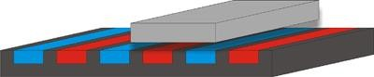

Fig 11.3 Planar Linear Motor

The ever-present problem of this type of motor is the vertical force of attraction between the primary and the secondary part. This force of attraction can be many times bigger than the horizontal propulsive force and must be compensated for using mechanical guidance (mechanical support) of the movable part. **11.3.2: Cylindrical (tubular) moving magnet linear motors**:

1L06-tubular3

Another type is seen when the plane of the coils and the magnets are rolled back around an axis. The movement of the motor is oriented along the axis.

Fig 11.4 Cylindrical (tubular) moving magnet linear motors

The primary part is arranged around the cylindrical part of the secondary part. The primary part thus forms an outer cylinder and the secondary part an inner cylinder. In another solution, the primary part forms the inner and the secondary part forms the outer cylinder.This means that either the primary or the secondary part can be moved.

## 11.Induced Voltage Measurement:

To grasp how electrical machines work, it is important to understand the interaction between electricity and magnetism .A key result of this interaction is the induction of a voltage in a wire or a coil. Let us explain the generation of this induced voltage using the example of linear motor.

The following fig 11.5 shows the magnetic track of a linear motor. Alternate magnets have different poles facing upwards (north or south), as shown here in red and blue. When a coil is moved left to right over this arrangement of magnets, an induced voltage (induced in the coil) can be detected by a voltmeter. This changes sign depending on the coil's position over the magnets .



Fig 11.5 Magnetic Track

The primary part of the motor consists of three coils that give rise to phases U, V and W. The coils or so arranged that the induced voltages in these coils have a phase difference of 120°. This is fundamental to alternating current technology.

## : How the induced voltage is produced:

A voltage is induced when a conductor is moved through a magnetic field characterized by its magnetic flux **Φ.** As shown in the next picture, the induced voltage changes depending on the polarity of the magnet. Similarly, a voltage is generated in a coil when the magnetic flux **Φ** enclosed by the coil changes. In a linear motor, the flux changes in the coil when the coil is moved over the surface of permanent magnets with alternately facing poles.

Mathematically this can be expressed by the formula:

### u = - N dΦ∕ dt

which is called "Faraday's Law".

In the formula above the following quantities are used:

u = Induced voltage in volts

N = Number of turns in the coil Φ = Magnetic flux in webers

t = Time in seconds

## :The following should be noted:

THE INDUCED VOLTAGE DOES NOT DEPEND ON THE FLUX ITSELF; IT IS THE RATE OF CHANGE OF FLUX WHICH IS RESPONSIBLE FOR THE INTENSITY OF THE INDUCED VOLTAGE.

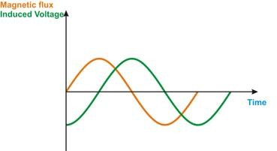Therefore, if the flux waveform is sinusoidal, the induced voltage also follows a cosine/sine function. This is illustrated in the next figure 11.6. The induced voltage reaches its maximum value when the flux changes its sign. Due to the minus sign in the formula, the induced voltage is positive when the flux has a negative gradient and negative when the flux gradient is positive.

Fig 11.6 Flux and Induced voltage waveforms

In this experiment the relationship between the induced voltage and the speed of the rotor will be investigated.

## Procedure:

Move the rotor over the magnetic track at different speeds and measure the induced voltage.

## Slow Movement:

* + - 1. Assemble the circuit and wire up the linear motor as shown in fig 11.7

Use channel A of the oscilloscope to measure the voltage induced in winding U. Configure the oscilloscope as follows:

|  |  |
| --- | --- |
| Instrument: | Oscilloscope; single measurement |
| Timebase: | 100 ms/div |
| Channel A: | 1 V/div; DC |
| Channel B: | Off |
| Trigger: | Channel A; rising edge |
| Trigger level: | 0.5 V approx. Trigger delay 0 |

* + - 1. Move the primary part of the linear motor slowly from left to right and record the voltage across the coil.
      2. Repeat the experiment until you obtain a smooth trace on the oscilloscope. Take care to move the coil at as regular a speed as possible.

## Fast movement:

1. Repeat the experiment moving the primary part quickly over the track.and plot the graph.

## Circuit Diagram:

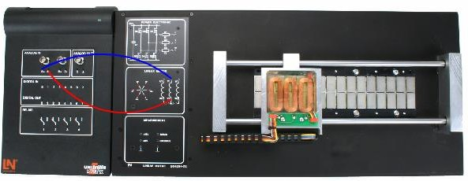

Fig 11.7 Circuit Arrangement

## Observations:

Copy the resulting trace into the space below for slow movement.

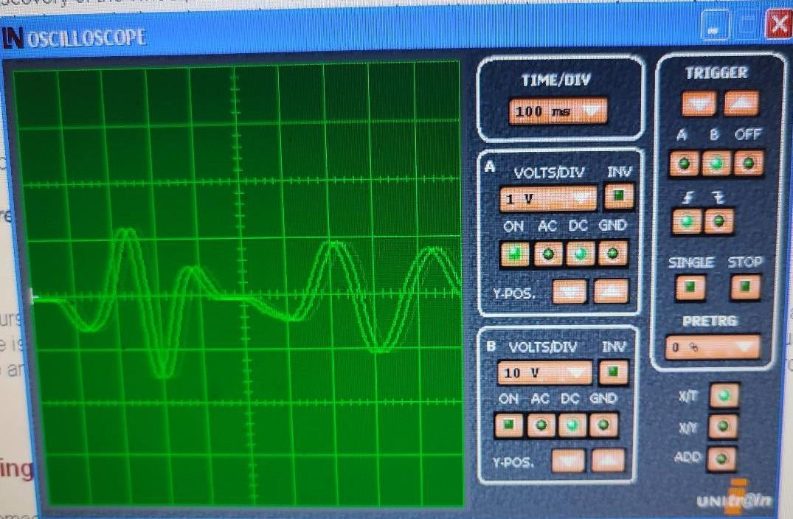

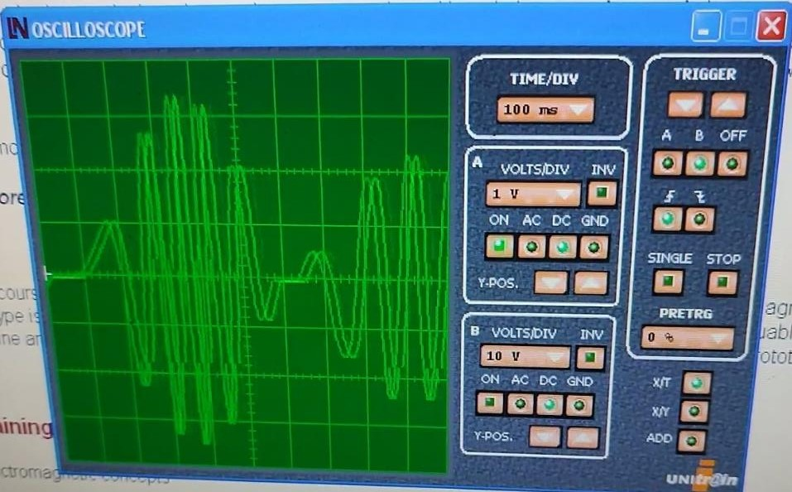

\ Copy the resulting trace into the space below for fast movement.

## Lab Exercise :

***Task 11.1:*** Compare the Induced voltage in both cases for slow and fast movement and describe your observations.

**Conclusions:** Describe your observations and comments in space below